**Account Package**

This package contains the use cases that pertain to a User’s ability to create and interact with an account in the StayConnected system.

Login

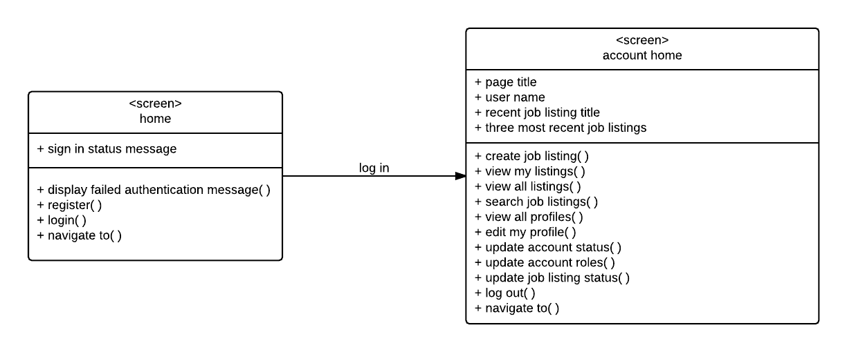

Create Account

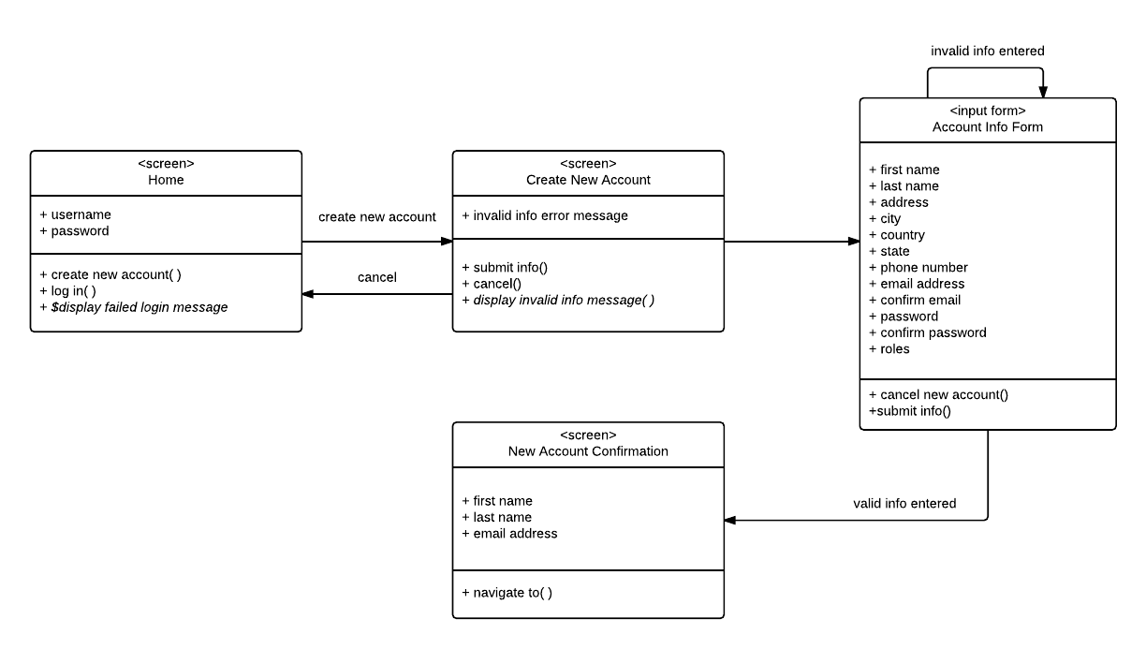

Edit Profile

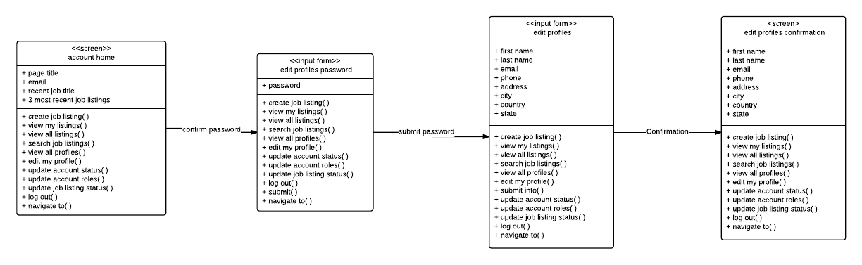

Activate Account/Deactivate Account (Admin)

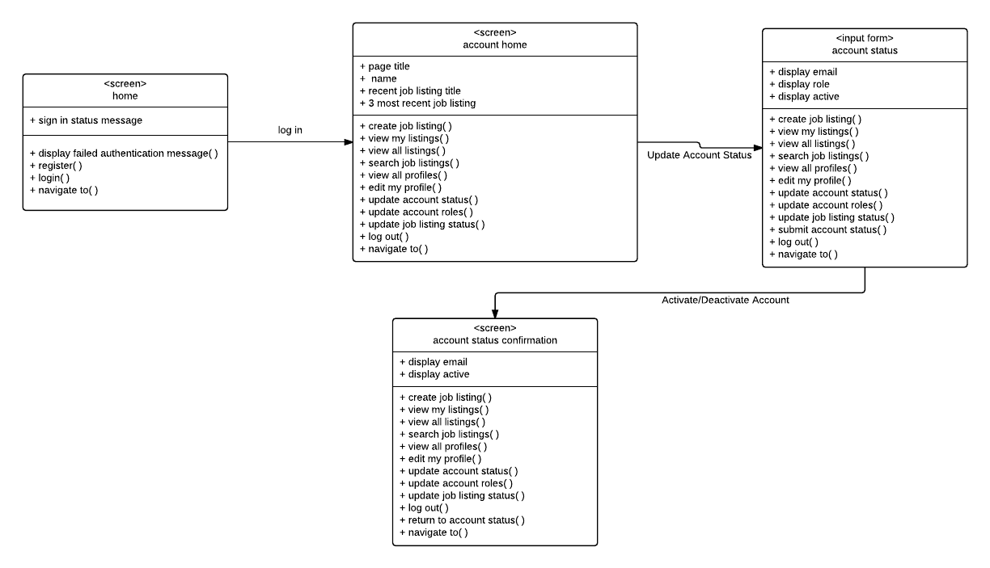

Update Account Roles (Admin)

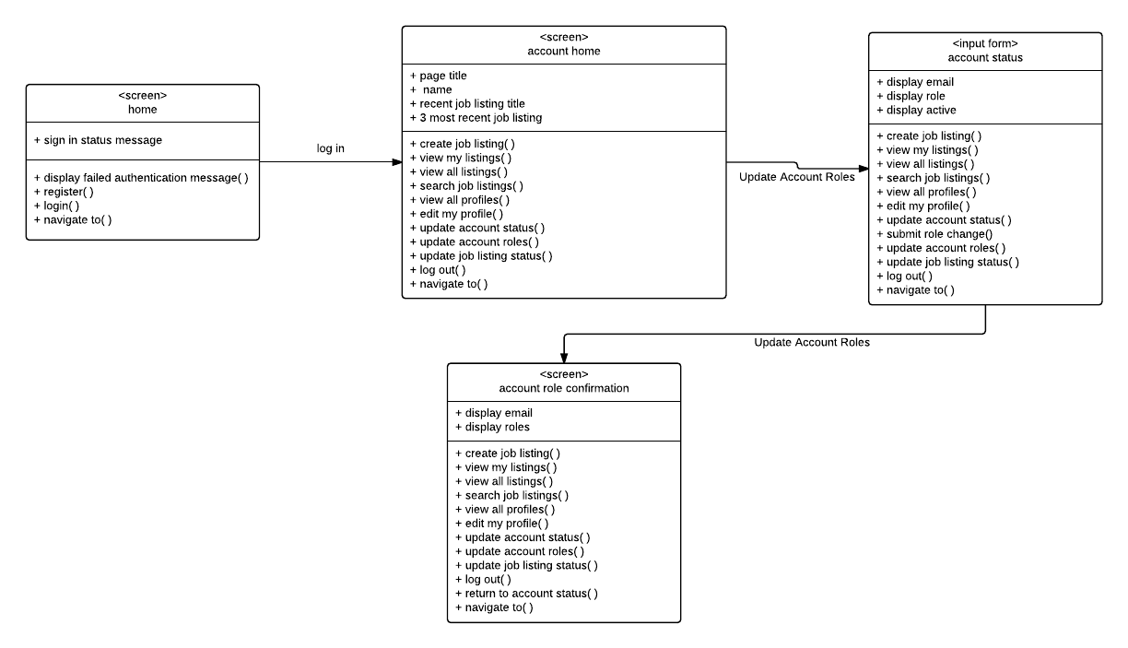

View Profiles

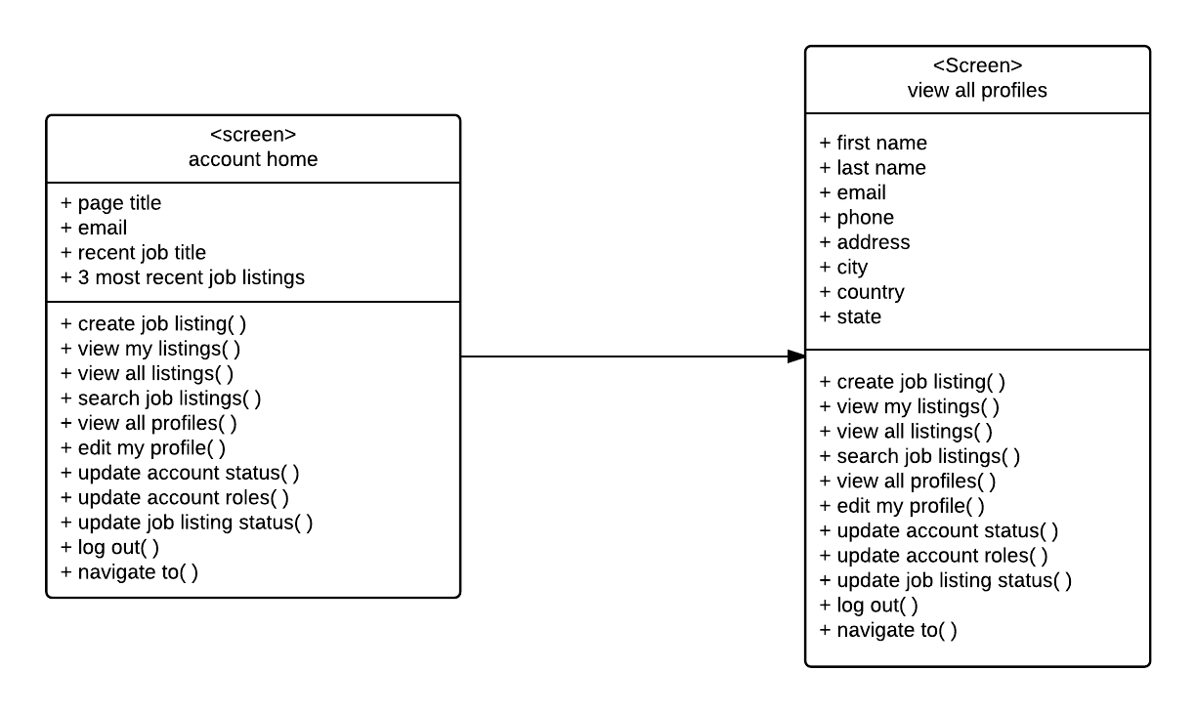

Logout

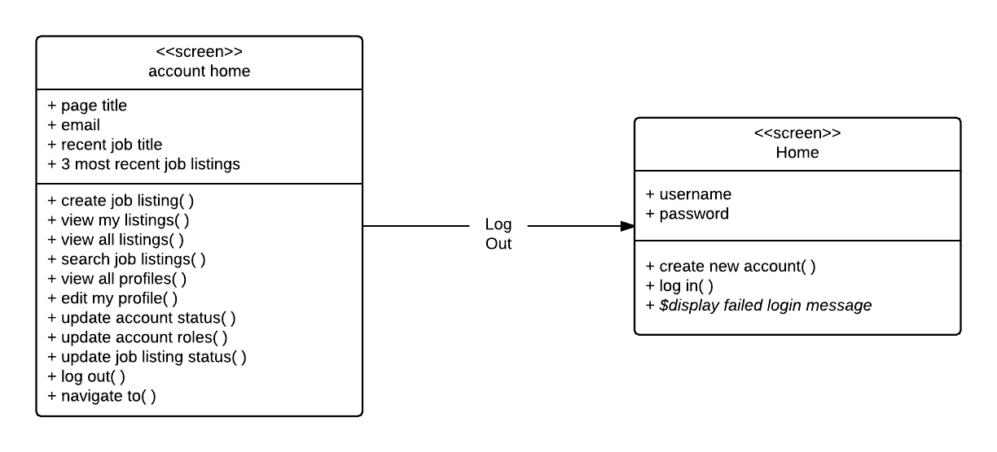

**Job Package**

This package contains the use cases that pertain to a User’s ability to create and interact with job listings in the StayConnected system.

Create Job Listing

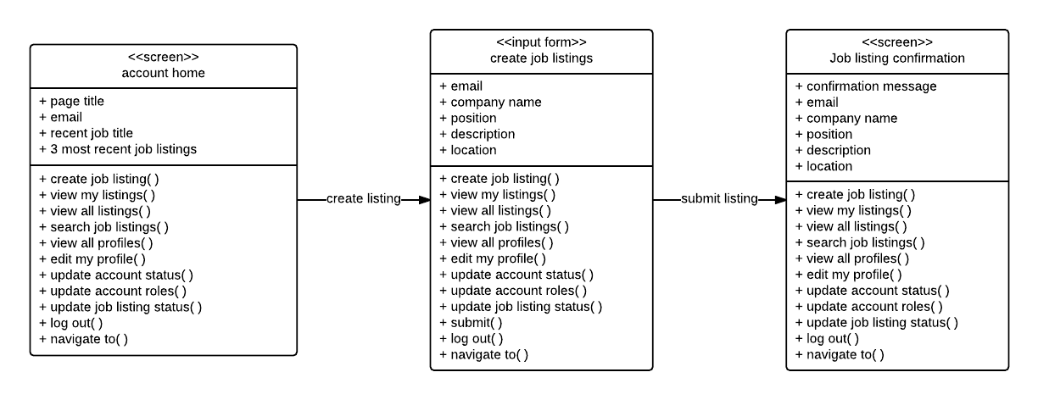

Update Job Listing

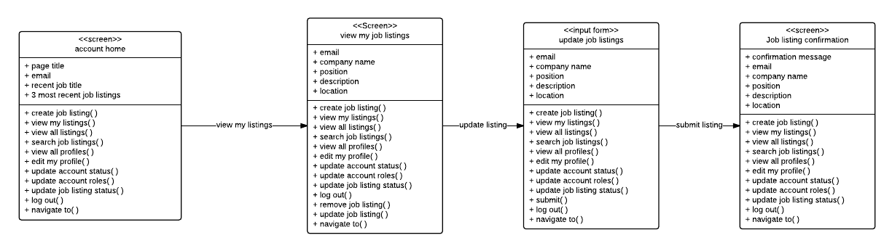

Search Job Listing

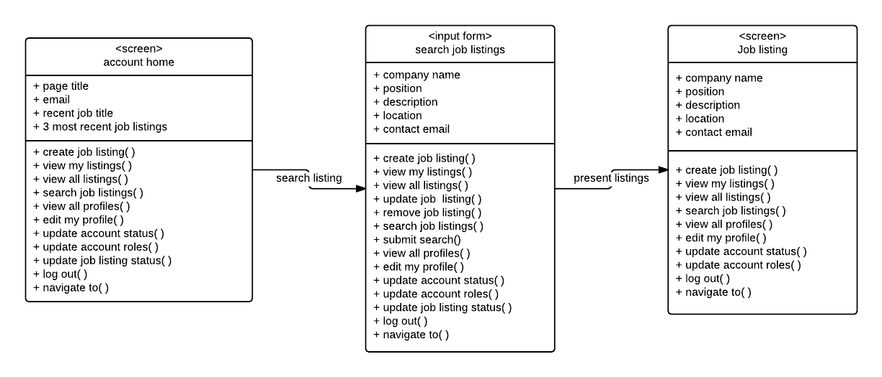

Deactivate Job Listing (Owner)

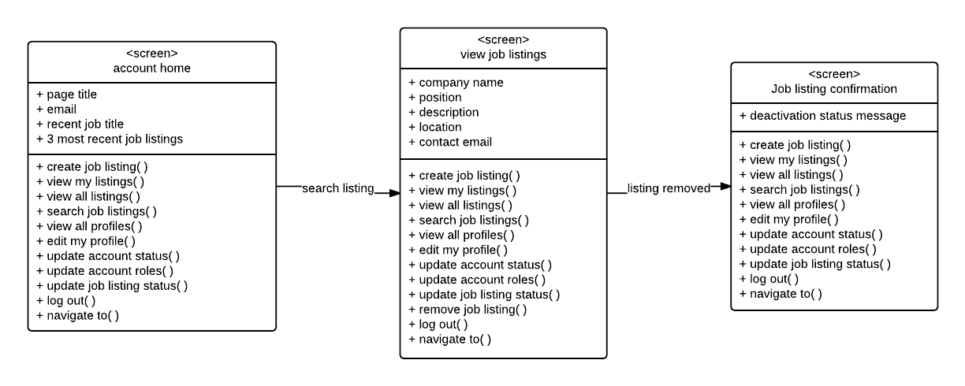

Deactivate Job Listing/Activate Job Listing (Admin)

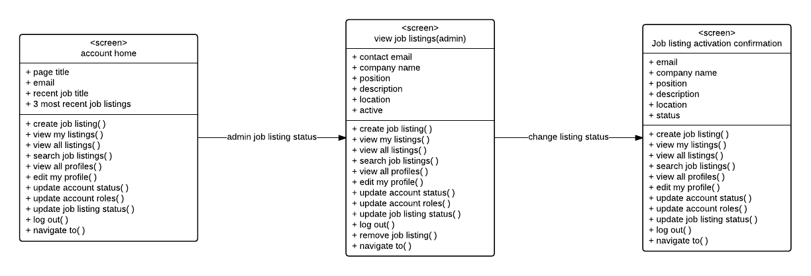

View Job Listings

